26 June 2025

Dear Dr.,

Greetings in Jesus’ name. Thank you for your reply and interest in post-graduate training in one of the CAAP specialty residency programs. CAAP is a network of Christian primary care residency programs (Family Medicine, Internal Medicine) in African mission/church hospitals that seek to mentor and disciple African Christian physicians who want to serve in underserved areas, living out the good news of healing in Jesus’ name in Africa.

**Our Purpose Statement:**CAAP builds up and strengthens primary care residency program*s* and faculty, collaborating with partner church hospitals to see African Christian physicians leading robust primary health care teams who demonstrate exceptional medical skills, spiritual maturity, and missional focus.

CAAP fulfills its mission by providing consultations to aspiring programs, resources for developing clinical, spiritual and professional development curricula, short and long-term faculty recruitment and preparation, and sourcing of scholarship support.

CAAP itself does not itself operate residency programs or take applications from potential applicants. In order to be considered for a program entry you will need to apply directly to each of the following CAAP-affiliated residency programs.

CAAP encourages those interested in primary care post-graduate specialty training to consider affiliated programs in the specialty of family medicine. Family Medicine is a specialty that prepares the “consultant to the primary care team”. It encompasses internal medicine within a broad-based education preparing for service in district/zone level hospitals that is sensitive to community needs. Currently there are five partnering Christian teaching hospitals of the Kabarak University Family Medicine Residency in Nakuru, Kenya. Please write:

* **Kabarak University Department of Family Medicine**, Nakuru, Kenya   
  Training is in English; patient care is in Kiswahili.   
  Contact Dr. Jonathan Nthusi, Department Head: head.familymedicine@kabarak.ac.ke

CAAP-affiliated internal medicine residency programs are:

* **Christian Internal Medicine Specialization**, Mbingo Baptist Hospital, Cameroon   
  Training is in English. Patients speak French or English.  
  Contact Dr. David Sunday, Program Co-Director: sun2dav@gmail.com
* **Harpur Physician Training Program**, Harpur Memorial Hospital, Egypt   
  Training is in English; patient care is in Arabic.   
  Contact Dr. Ehab Ayoub, Program Director: [ehab@fastmail.fm](mailto:ehab@fastmail.fm)

God’s grace to you in your plans for future service for Christ and His kingdom.

Together in Christ’s service,

The CAAP Executive Committee



**Christian Internal Medicine Specialization (CIMS) - Mbingo Baptist Hospital, Cameroon**

The Christian Internal Medicine Specialization (CIMS) program started at Mbingo Baptist Hospital in 2008 under the guidance of Dr. Dennis Palmer. Over the past 15 years, the curriculum has been refined to the current educational structure. This includes clinical teaching, spiritual curriculum, formal assessments, and mentorship. The program lasts 4 years and accepts 4 residents per year. Since the beginning of the program, CIMS has produced 25 internal medicine residency graduates with almost all of them currently working in Christian hospitals in Cameroon. In addition, multiple residency graduates have gone on to subspecialty training in the following fields: oncology, radiation/oncology, pathology, critical care, cardiology, and gastroenterology. Some of the graduates have stayed at Mbingo and now make up a significant portion of the current residency program teaching faculty. The residents are chosen based on a holistic review of their spiritual maturity, academic accomplishments, and desire to serve in a mission hospital setting. Each year there are many more applications than can be accepted and this has led to well-qualified residency classes. As the program has matured, the graduates have only improved further and now the graduates are well-trained and dedicated to serving in a Christian mission hospital setting. The framework for the CIMS curriculum is now serving as a guide for future internal medicine residencies at mission hospitals through the partnership with CAAP.

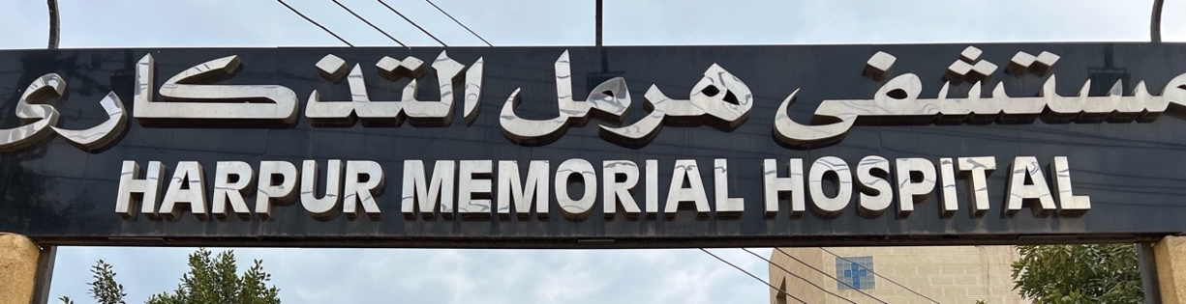

**Harpur Physician Training Program (HPTP) - Harpur Memorial Hospital, Menouf, Egypt**

The Harpur Physician Training Program (HPTP) at Harpur Memorial Hospital in Egypt started in May 2023 with the acceptance of the first 2 residents into the program. Before that time, CAAP was heavily involved in working with the Harpur leadership in preparing for the start of the program. Some of this included building a curriculum for the program. The curriculum is heavily based on the successful internal medicine program in Cameroon (above) with some modifications to fit the Egyptian healthcare model and licensing requirements. CAAP was also involved in faculty development, establishing a spiritual curriculum, and ongoing support in these and other areas. In addition, CAAP sent a consultation team to Egypt to work with Harpur Memorial Hospital in February 2023 before the start of the residency program. This led to a comprehensive report that highlighted the strengths of the hospital and future residency as well as areas of focus for improvement. CAAP continues to have a deep relationship with the leadership of the HPTP program at Harpur and is committed to seeing its success in training Christian internal medicine physicians in Egypt.